Admission step by step
In this section we will explain step by step the process to apply and subsequently enroll in our masters. You should look carefully at the deadlines on the side link ( Deadlines and Academic Calendar ) to make sure you are within the admission period. There will be a second period, but only for those masters who have not covered the total of their places.

Select your master
In the UAM you can choose from more than 8 or 0 official university master's degrees, so we encourage you to consult our offer in the side menu (List of Official Masters).
If you debate between several options, keep in mind that with the single payment of the administrative fees of € 27.54 you can make three requests of your choice. Remember to sort them in order of priority since this can influence the coordination of the coordinators.
Each master's degree requires specific profiles and training, so you should check this information to match the recommended profile. On the other hand, there is some documentation that you must provide common to all masters and other particular for some of them. You must make sure you have all the documentation in individual electronic files. The maximum size of each file cannot be larger than 4 megabytes.
The documentation common to all masters is as follows:
- ID / Passport .
- Curriculum Vitae (cv). The vast majority of masters accept a free cv format but some require a special format, so you should check it on the master's own page.
- Academic certification of grades: this document contains, among other information, the enumeration of subjects of your Degree and the grades obtained in each one of them . It is not necessary that the certificate be issued by the administration of the center, it would be worth the document that you can download from the digital platform of the university where you have studied.
- Certificate of the average grade of the subjects taken so far on a numerical scale from 0 to 10. Like the certification of notes it is not necessary that the certificate be issued by the admission of the center and would be worth with the document that you can download from the digital platform. Many certifications of notes include at the end of them the average obtained so far in numerical scale from 0 to 10, so, if this is your case, you would not need to provide this other document.
In the event that Spanish students could not obtain the average grade on a scale of 0 to 10 from their original university, the equivalence detailed in the document of the download area will be applied ( Table Equivalence Scales ).
For students who have completed their studies at universities outside of Spain, the equivalence of the average grade must be provided through the platform of the Ministry of Science, Innovation and Universities . We provide you with the email so you can consult the doubts that may arise when using this platform : notamedia.uni@ciencia.gob.es
- Final declaration of studies only for those students who request the master without having finished the degree. They must indicate their commitment to finish them by giving an approximate date, taking as reference the calls for June or September of the year in which they apply for the master.
In addition to these documents you should consult the page of the master himself if he requires any other particular document such as itineraries, letters of recommendation, language level certificates ...
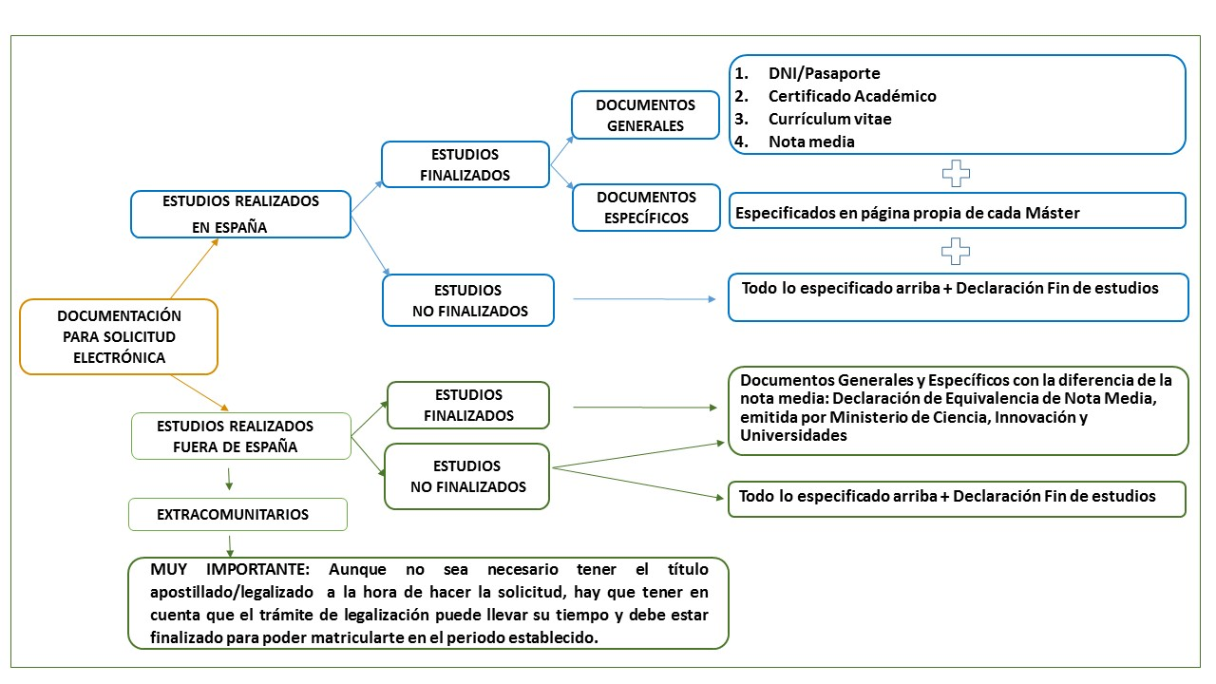

Get your username
Once you have gathered the documentation in digital format, the next step is to register in our system.
- If you have not been a student of the UAM you can obtain your username and password here . In the download area you will find a manual to fill in the user data ( Instructions for registering a user ).
- If you are or have been a student of the UAM you must use your keys to make the application for admission and if you do not remember them, you can retrieve them here .
These keys will help you to consult your request at any moment of the process and finally to enroll, so we recommend that you have them on hand.

Make the request
- If you are a former student of the UAM you can already apply by clicking here
- If you are a new student you can apply here
Remember that for your application to be processed you must pay the administrative fees of € 27.54 for opening the file. After the payment of the fees, the application goes from being in " TEMPORARY APPLICATION " to " REQUESTED BY THE STUDENT ".
If you encounter difficulties when making the request you can download the PDF file in the download area ( Instructions for master's application ).
When you can make up to three applications, remember to assign the correct preference to each of them, and that you can only enroll in the application you are admitted with the highest priority. If at any time before enrollment you change your mind, you can tell us at postgraduate.oficial@uam.es and we will modify the preferences in your requests.

Phases through which your request will pass
The application initially presents the status of " TEMPORARY APPLICATION " and once the fees of € 27.54 have been paid, it will be registered in our system showing the “STUDENT REQUESTED” status. Now it will be reviewed by the administrative staff of the UAM to verify that nothing is missing. If so, the request will go to the status of "VALIDATED BY ADMINISTRATION" . If the request needs some correction, we will inform you by email that you must correct some point in order to continue processing it.
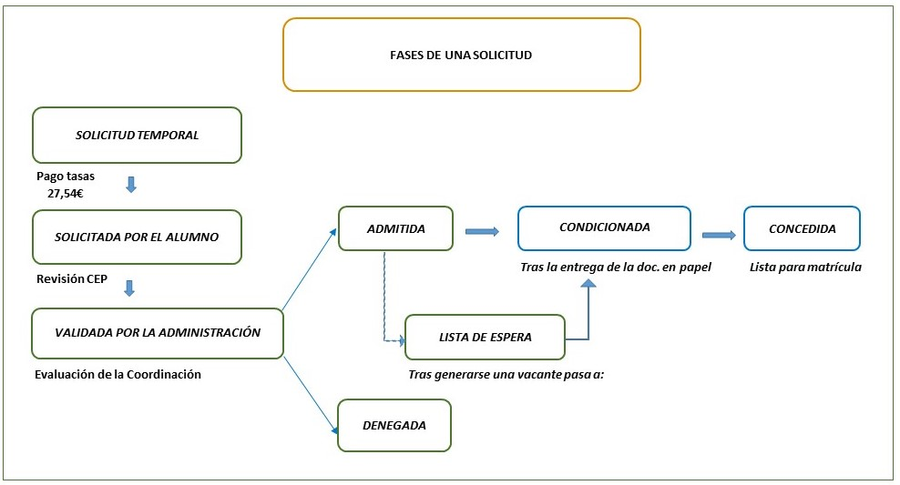Once validated, your application will be evaluated by the Coordination of the Master. This step is not automatic since the coordinators have deadlines described in the academic calendars to evaluate the applications they receive.
After the evaluation you will be informed by email of the new status of your application and in the case of being “ADMITTED” you will be asked to provide documentation, this time on paper , to verify the documents and thus be able to give way to registration. In the case of not having obtained admission, you will be informed of the causes also by email.
You should know that each application will carry an independent rhythm and that the admission in one of them does not paralyze the course of the others. The applications will be processed individually from the beginning of the process until the end and you will have the evaluation of all of them in their corresponding term.
The UAM students and graduates receive the letter of "definitive admission" so they can register directly. The conditioned Admission Letter will be received if you have not finished your studies or when you must submit a specific document in a particular master's degree.

Provide paper documentation
!! Congratulations!! because this step implies that you have been admitted by the Coordination and you only need to deliver certain documents. Therefore, you will receive an email with the attached Conditional Admission Card, which lists the documentation to be delivered and the deadlines for doing so. At this point we must specify two things:
- Paper documentation to contribute
- We will ask you to provide a certified photocopy of the title with which you access the master's degree or, if you do not already have your degree, of the proof of having paid the fees for obtaining it. This document is what you generate in the administrations of the Center to pay the shipping fees of the same in a bank. Make sure that this document you provide is a copy, since the original will be the proof that you must give to collect the official degree.
- You must provide a certified copy of the ID / passport.
- In some masters we will ask you to deliver a certified copy of the language level certification.
- If you are an extra-community student you must provide the duly legalized and authenticated access title so you should pay close attention to the Legalization section so that you can provide the correct documentation and in due time. Check the link in the “Legalization and Translation” side menu.
- How can you send the documentation to our Center and what are the possible situations in which you can find yourself?
- If your home university has an online digital verification platform and issues the documents with an electronic signature, you will not need to provide paper documentation. In that case, sending the PDF documents to postgraduate.oficial@uam.es with the electronic verification code is sufficient, since we can check it online.
- As a general rule, certified photocopies of the degree are obtained in the universities of origin, and the compulsory ones of the DNI in police stations, town halls, public state agencies that lend themselves to it. Once you have the certified copies you can deliver them in person at the Postgraduate Study Center (you or anyone you know in your name) or send them by registered mail or courier.
- You have an alternative to the compulsa by bringing the originals and photocopies to our Postgraduate Studies Center and in Student Services you will check the documents you submit.
- You can send your documentation to our General Registry through a Public Registry office .
If upon receiving the conditional admission letter you have not yet completed, you must answer our email confirming the date of completion and obtaining the title. It will be registered in your profile in order to properly track your situation and interest. In the case of being from the UAM you must notify us when you have applied for the title so that, once reflected in our computer system, we can give you the way to registration.

You can already enroll
When we have reviewed and approved the documentation you have submitted, we will send you the final Admission letter attached in an email. You are just one step away from finishing because that email will contain the link by which you can self-enroll, wherever you are and at the time you want. Of course, you must do it within the period indicated.
In the event that you have the right to a bonus for honors or that you belong to a large family, or in the case of having a disability certificate , you must approach the Administration of the faculty / school in which the Master's degree so that you can apply the corresponding benefits before enrolling.
From this point the Administrations of the faculties / schools will help you with the incidents you find in the enrollment process and others.

